**The Volatility of Uranium Prices**

Brenden Brown

HSA 10-5 The Economics of Oil and Energy

April 5, 2016

**I. Overview**

In this paper I will be exploring the causes of the volatility in the uranium price market. I will first discuss some necessary background information about what uranium is and what it is used for to see why examining the volatility in the uranium price market even matters. This paper will then provide some further background information on the main players in this market before going on to analyze the uranium price market itself and drawing conclusions as to the causes of its volatility.

**II. Background**

Uranium is a radioactive heavy-metal that is mined from the Earth’s crust [3]. The mined uranium is refined, and that product is then used in powering nuclear reactors, an alternative method of energy production that arose in 1945 following the development of the atomic bomb [2]. In this paper, we will only be concerning ourselves with the economics pertaining to pure uranium ore, but in reality there are many steps in the refinement process before it can be used in nuclear reactors.

Nuclear reactors are very complicated works of engineering and their designs all vary slightly, but the basic premise of a nuclear reactor is that radioactive elements undergo fission to heat up water to turn turbines and produce electricity. This process can be visualized in more detail by looking at Figure 1.

Fig. 1. How nuclear power plants work.

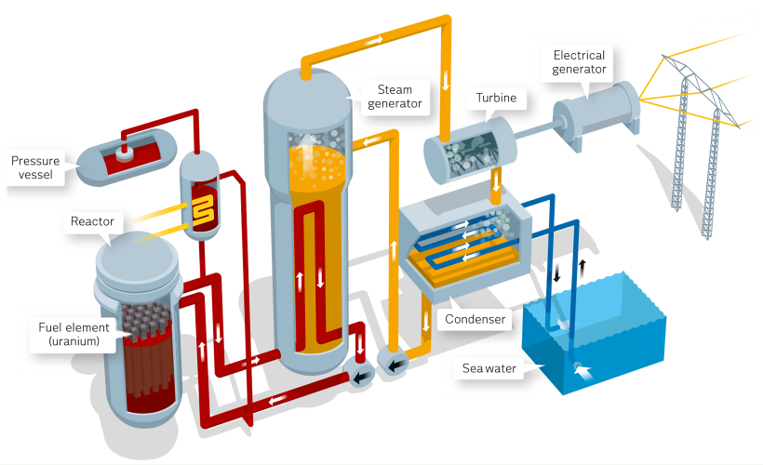

<http://corporate.vattenfall.com/about-energy/non-renewable-energy-sources/nuclear-power/how-it-works/>

As of recently (2012) only about 12% of the world’s electricity is generated by nuclear power, and expert predictions have this number falling [1] (see Figure 2). This is likely a result of the known volatility of uranium prices, which is why we want to examine its cause in more depth.

Fig. 2. World electricity predictions to the year 2040.

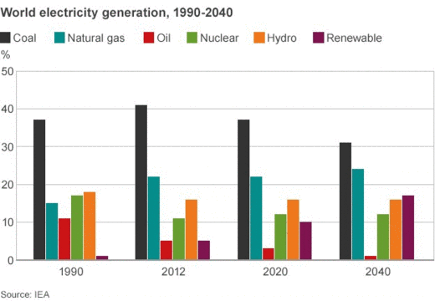

<http://www.bbc.com/news/business-30919045>

**III. Who, What and Where?**

Before we continue on to analyzing the price market of uranium, we would like to give some better background on the groups in control of the world uranium supply. This will help us later in understanding some of the behavior in the uranium price market.

Uranium is commonly found in rocks and seawater, but is not uniformly concentrated around the world (although it is relatively spread out). Most uranium is concentrated in Australia (29%) and Kazakhstan(12%), with several other countries coming in at around the eight and nine percent range [4]. While these numbers are not inherently impressive, what is impressive is the extremely small number of companies that dominate the mining industry of uranium. There are currently five companies (Specifically Cameco and AREVA who lead by an overwhelming majority) that dominate the uranium mining industry [5]. Because of this the supply of uranium, at least for a while, was very limited, causing what is known as inelastic supply, which we will discuss next.

**IV. The Volatility of Uranium Prices**

Now that we have ample background information, we can proceed to analyze the volatile uranium price market and provide an explanation for the cause of this problem. To begin, we have to understand the basics of supply and demand. For the majority of its history (we’ll talk more about the contemporary events in a bit) the supply of uranium has been inelastic, as we’ll look at later. This means that the supply doesn’t really change, due to the small number of companies that mine uranium which causes a decrease in how quickly the supply can increase and decrease (i.e. a vertical line on supply-demand curve, see Figure 3 below). By having inelastic supply, the price of the product, in our case uranium, follows almost directly, the demand market for that product.

Fig. 3. Inelastic Supply Curve.

|  |
| --- |
| economics15.gif |

<http://www.investopedia.com/university/economics/economics4.asp>

Since, only a few companies dominated the mining of uranium because it is not readily available everywhere the inelasticity of the supply makes sense; the suppliers have little competition so they can completely control the supply and limit it however they want. As said earlier, this inelastic supply means that in essence the price follows the demand.

We’ve found that demand is mainly driven by the consumer, as is the case with most forms of energy [7]. Nuclear development is very expensive and requires the public’s support to build. Thus, the consumer drives demand for nuclear power, making it more prone to be volatile. People’s opinions on nuclear power can, and has been shown to, change so quickly and frequently, that the demand behaves sporadically, and thus, the price market has becomes extremely volatile.

But where does this fickle demand really stem from? The answer is fear. People fear the threat of nuclear meltdowns and investors fear that the price market is too unpredictable to invest in [8]. This is a viscous cycle that has continued to keep the price market of uranium volatile.

Now that we understand some of the details of the supply and demand behavior of the uranium price market, we can examine the actual data on the uranium price market as seen in Figure 4.

Fig. 4. Price-production relationship for Uranium.

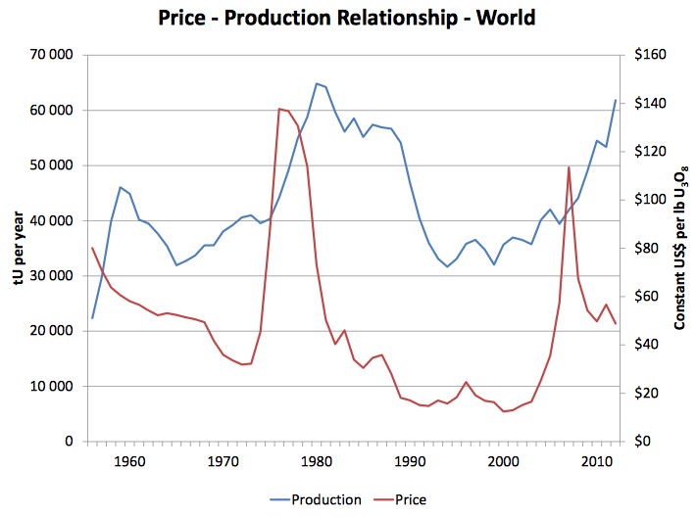

<https://www.iaea.org/OurWork/ST/NE/NEFW/Technical-Areas/NFC/documents/uranium/tm-isl-2013/02.Pool_2013_U_supply_demand_prices.pdf>

As we can see, starting from about 1965 all the way to 2005, the plot showing uranium prices almost directly corresponds to the plot of the production values (i.e. the demand). This is a result of the inelastic supply of uranium as mentioned above.

Let’s now look specifically at the dramatic price drop of uranium in the 1980s. This dramatic price drop directly corresponds to the horrendous Chernobyl meltdown[1] that occurred in the Ukraine in 1986 (fallout depicted in Figure 5 below). The ramifications of this tragic event are an example not only of the inelasticity of the uranium price market, but also the extreme volatility.

Fig. 5. Chernobyl Meltdown.

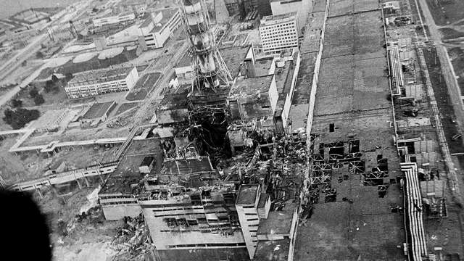

<http://graphics8.nytimes.com/newsgraphics/2014/04/02/chernobyl/assets/images/reactor-640.jpg>

After 2005, this trend of inelastic supply no longer seems to be the case. We now see a decrease in price with a rise in production, likely the result of a no longer inelastic supply of uranium. This occurrence stems from two reasons: 1) New technology in mining caused an increase in supply, making the uranium supply market no longer as inelastic and 2) A new deposit of uranium ore was discovered, causing a spike in supply, once again resulting in a not as inelastic behavior of uranium supply [6]. “Over 2005 and 2006 exploration effort resulted in the world’s known uranium resources increasing by 15% in that two years.” [6].

Now we ask ourselves, “If supply is no longer inelastic, why is the price market still volatile?” The answer to this is not as complex as we might think. Despite new advances in technology, events like Chernobyl or the Japanese Fukushima Accident[2] sit in the back of peoples mind, unconsciously changing their views. Even though the supply of uranium has become more elastic, and thus more independent of demand, it is still in part driven by demand and continues to be volatile due to the ongoing debate on the safety and expenses of nuclear power, and its merits as an energy source.

**V. Concluding Thoughts**

If we look past the recent developments in the uranium market (2005 – present), we have shown that uranium is a market driven by demand, due to the inelastic nature of its supply. This inelastic behavior caused by the fact that a small number of companies dominate the uranium mining industry, leaving the market trends to be determined by the demand of the people and investors. The uranium demand market itself is volatile due to people’s fear of nuclear meltdowns and investors fear over the instability in the market. Thus, since the demand market is so fickle, the uranium price markets behavior is so volatile.

Additionally, the fear that causes the volatility described in the pre-2005 period has carried over and continues to be the cause of the sustained volatility of the uranium price market. However, let it be said that this volatility is becoming more stable as supply becomes more elastic. We may see the market stabilize in future years if people begin to reconsider nuclear power and the supply continues to become more elastic.

[Word Count: 1,492]

References

[1] Anderson, Richard. "Nuclear Power: Energy for the Future or Relic of the Past? - BBC News."*BBC News*. BBC News, 27 Feb. 2015. Web. 06 Mar. 2016.

[2] "Outline History of Nuclear Power." *History of Nuclear Energy*. World Nuclear Association, n.d. Web. 06 Mar. 2016.

[3] "What Is Uranium? How Does It Work?" *What Is Uranium? How Does It Work*. N.p., n.d. Web. 06 Mar. 2016.

[4] "Supply of Uranium." *Uranium Supplies: Supply of Uranium*. N.p., n.d. Web. 06 Mar. 2016.

[5] Moran, Kristen. "Top Uranium-producing Companies in the World." *Investing News Network*. N.p., 06 Oct. 2015. Web. 05 Apr. 2016.

[6] "Uranium Mining Overview." *Mining of* *Uranium: World Nuclear Association*. N.p., n.d. Web. 06 Mar. 2016.

[7] Adeyanju, Craig. "The Top Factors That Move the Price of Uranium." *The Top Factors That Move the Price of Uranium*. N.p., 13 Aug. 2014. Web. 06 Mar. 2016.

[8] Johnson, Keith. "What's Holding Back Nuclear Energy." *WSJ*. Wall Street Journal, 11 Nov. 2013. Web. 06 Mar. 2016.

[9] "Chernobyl Accident 1986." *Safety of Plants: World Nuclear Association*. N.p., n.d. Web. 06 Mar. 2016

[10] "Fukushima Accident." *Safety of Plants: World Nuclear Association*. N.p., n.d. Web. 06 Mar. 2016

Works Cited

Adeyanju, Craig. "The Top Factors That Move the Price of Uranium." *The Top Factors That Move the Price of Uranium*. N.p., 13 Aug. 2014. Web. 06 Mar. 2016.

Anderson, Richard. "Nuclear Power: Energy for the Future or Relic of the Past? - BBC News."*BBC News*. BBC News, 27 Feb. 2015. Web. 06 Mar. 2016.

"Chernobyl Accident 1986." *Safety of Plants: World Nuclear Association*. N.p., n.d. Web. 06 Mar. 2016

"Fukushima Accident." *Safety of Plants: World Nuclear Association*. N.p., n.d. Web. 06 Mar. 2016

Johnson, Keith. "What's Holding Back Nuclear Energy." *WSJ*. Wall Street Journal, 11 Nov. 2013. Web. 06 Mar. 2016.

Moran, Kristen. "Top Uranium-producing Companies in the World." *Investing News Network*. N.p., 06 Oct. 2015. Web. 05 Apr. 2016.

"Nuclear Power - How It Works." *Vattenfall*. N.p., n.d. Web. 06 Mar. 2016.

"Outline History of Nuclear Power." *History of Nuclear Energy*. World Nuclear Association, n.d. Web. 06 Mar. 2016.

"Pros and Cons of Nuclear Energy - Conserve Energy Future."*ConserveEnergyFuture*. N.p., 07 Mar. 2015. Web. 05 Apr. 2016.

"Supply of Uranium." *Uranium Supplies: Supply of Uranium*. N.p., n.d. Web. 06 Mar. 2016.

"Uranium Markets." *Uranium Markets: World Nuclear Association*. N.p., n.d. Web. 06 Mar. 2016.

"Uranium Mining Overview." *Mining of* *Uranium: World Nuclear Association*. N.p., n.d. Web. 06 Mar. 2016.

"Uranium Prices." *Denison Mines Corp.* N.p., n.d. Web. 06 Mar. 2016.

"What Is Uranium? How Does It Work?" *What Is Uranium? How Does It Work*. N.p., n.d. Web. 06 Mar. 2016.

1. In 1986, a flaw in the nuclear reactor in Chernobyl, Ukraine resulted in an explosion and a radiation leak. The event also caused two deaths of power plant workers and 28 deaths corresponding to radiation poisoning [9].
2. In 2011, a large Earthquake caused a tsunami that lead to power failure at a nuclear power plant. This event caused over 100,000 evacuations and over 1000 deaths as a result of the evacuation [10].